Assignment
- Write a function named f_charcount that counts the number of characters in a given text file. The function takes two arguments, fname a char array representing the file name/path and cquery a character vector representing the characters to be searched. The function returns a number array named cresult a vector that contains the count of each char in cquery. If the file is not found and the input is not a char array the function must return -1 and -2 respectively. Use simple.txt and AStudyInScarlet.txt to test your function.
- Write a function named f_avgdist that accepts an excel file with similar format as dist_1.xlsx and read it using the xlsread function. (You will need to install the io package in Octave and enable it) Your function should return a 2 cell arrays that points to each place (string) and to the average distance (numeric) from that place to the other places. (For each cell array the same cell index should return the corresponding average distance of each place)
- Write a simple shuffling ‘encryption’ algorithm as function f_crypto which takes a message msg as a character array and returns a shuffled message msgen and a random integer vector kou of the same length of the original message. The encoded message and the key kou can be used for decryption. If a message and a kin parameter is given it is assumed that the operation is to decrypt, given the msg only it will be the encryption operation. Use randperm and exist functions to generate a shuffled indexed key vector and check the function calling conditions. The generated key is a randomized indices for each character of the message to be rearranged. Optional: The encryption and decryption operations can be vectorized. Following is an example of using the function.
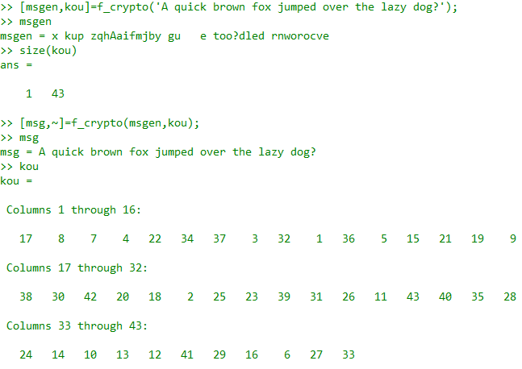

Submit your answer files bundled in a single zip file named by your index number.

